**ASSIGNMENT-7.6:**

Write a map reduce program save the output of the word count program in XML format. You need to write a custom writable to save the output in XML format.

Driver Class:

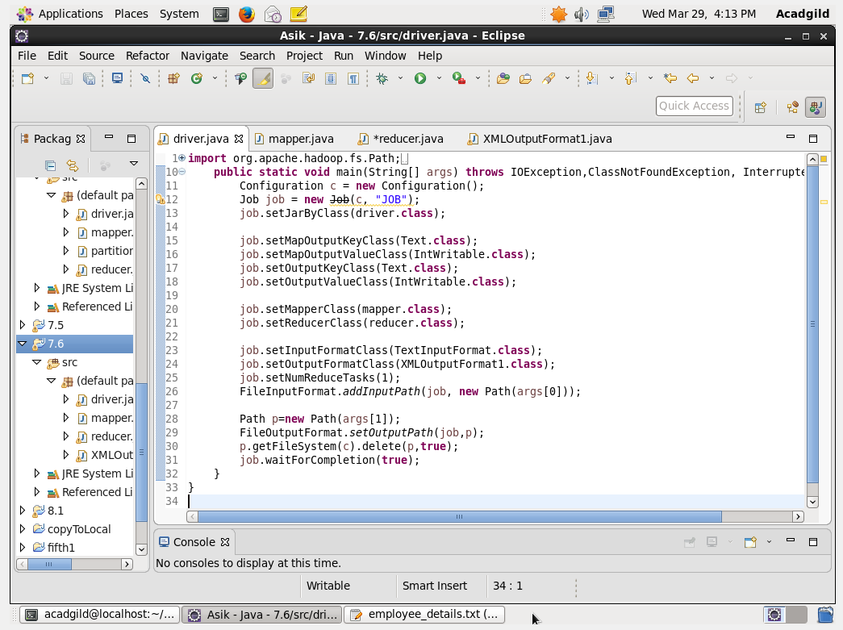

Mapper Class: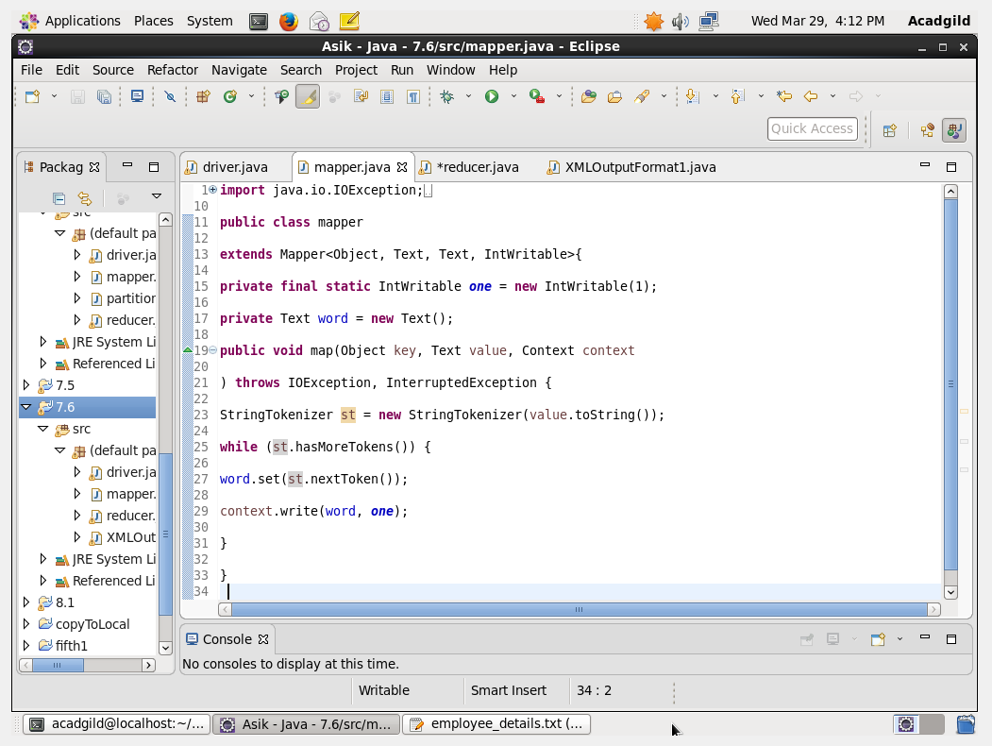

Reducer Class:

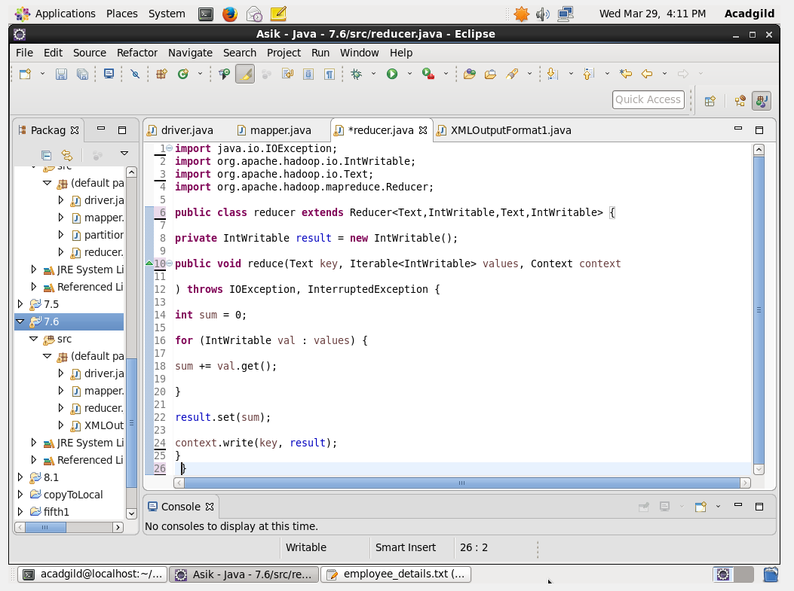

XML OUTPUT FORMAT CLASS:

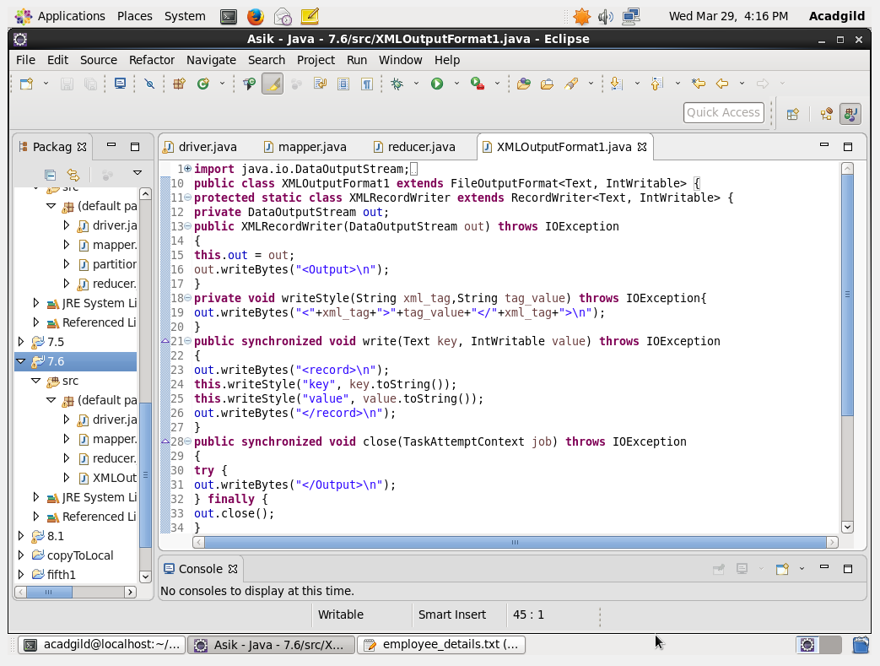

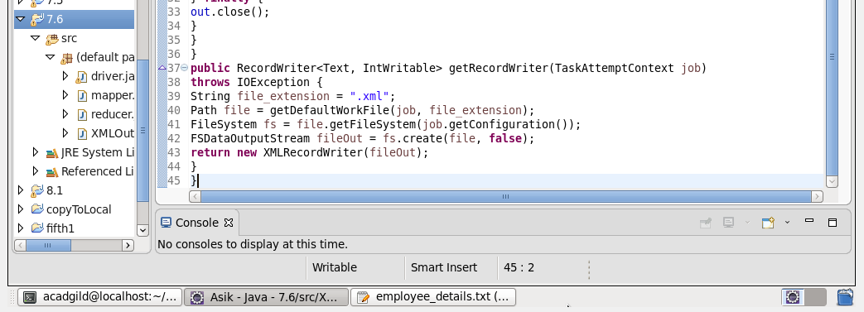

Executing the jar file:

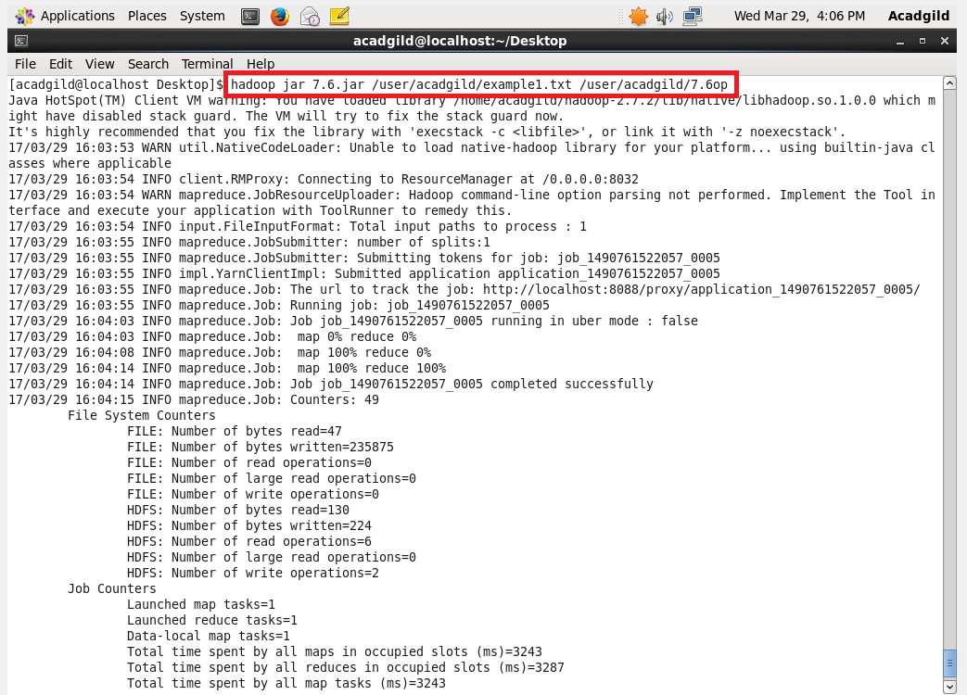

Output: